BEJEWELED GAME

## Introduction

Bejeweled is a tile-matching game developed by PopCap Games in 2001. It is a puzzle game where the player has to employ lateral thinking and strategy in order to match as many tiles as possible. The game for this assignment that has been made using SFML is a miniature bejeweled copy which includes many of the original game’s mechanics and playability. There are three modes available in the game supplied (the original had only two). Each mode is different in terms of both the strategy needed to get the best score as well as the gameplay. The game is a perfect example of in-depth puzzle solving where the player must incorporate future states of the tiles in their strategy in order to match as many tiles as possible.

A brief description of the game modes is provided henceforth:

### Classic:

The player continues to match tiles as long as there are matches still available on the board. In order to match tiles, the player can swap two adjacent tiles but that swap must always result in the matching of tiles. Once tiles are matched, they disappear from the board, and the tiles above them fall, and the empty space is taken up by new tiles. In this mode, a minimum of three tiles must be matched i.e. Three same tiles must lie next to each other in a line, horizontal or vertical only. There is a bar under the tile board which fills up as tiles are matched. Once it is completely full, the player level advances and he gets more points per tile matched, and the goal for filling the progress bar also increases. The more tiles are matched and the higher the level, the higher the score.

### Timed:

This mode is the same as classic mode, but with a time factor. The bar at the bottom of the board, instead of starting as empty, starts half filled and begins to deplete as time passes. The player can continue matching tiles until he runs out of time i.e. until the bar becomes empty, or until there are no matches left. As tiles are matched, the bar progresses, as with the classic mode, thus adding more time. It has the same level system as classic mode. The more tiles are matched and the higher the level, the more the score.

### Adrenaline:

This is a new innovative mode that brings a slight twist to the “puzzle” aspect of the game. Now, instead of worrying about the next state, the player must channel his cognitive skills to get the best match possible as he can swap any two adjacent tiles. This mode is like timed mode but the time depletes faster than the regular timed mode, and the player may swap any adjacent tiles even if the swap does not result in a match. Essentially, this means that there will always be a match available and it is a simple race against the clock. The more tiles are matched and the higher the level, the more the score.

As evident, bejeweled prompts the player to match three or more tiles whilst also keeping in view the state of the board after the match has happened, this adds more than just cognitive ability to the game and allows for a problem-solving puzzle strategy to be used.

# Objectives

The main objective of the game is to match as many tiles as possible in order to achieve the highest score. The game, in a sense, has no victory conditions as it continues until the player runs out of time or runs out of possible matches. Therefore, if two or more players are competing, the victor will be the one that has the highest score i.e. the one that has matched the most tiles. The lose conditions however, are pretty obvious. Either the player cannot match further tiles in classic or timed, or he runs out of time in timed and Adrenaline modes. The game ends when either of these conditions, in accordance with the mode, is met. One must keep in mind that the objective is not as simple as swap tiles to make a match where ever you see one. Instead, the player must also bear in mind the consequences of matching tiles and envision the future state of the board after the matched tiles have disappeared. Moreover, matching 4 or 5 tiles is better than matching only three, and getting more than one match is better than getting only one per swap. Thus, all these factors play a role in getting the highest score, thus making the objective more strategic instead of simply matching tiles.

# Mechanics

The game consists of a title screen with a play game button, which is to be pressed in order to get to the main gameplay screen. Upon pressing the start game button, a classic game of bejeweled starts. The window consists of an 8x8 board on the right side and interactive buttons on the left to choose the mode, get a hint or to restart the game. When the game ends, Game Over text is displayed over the board. The player may still interact with the board if he is a bad sportsman and thinks that there are still some matches left. After the game ends, one of the buttons must be pressed in order to start the new game. The exit button may be pressed at any point to exit the game.

In order to play the game, the player must click on two tiles that they want to swap. The two tiles must be adjacent, if not then nothing happens. Moreover, the swap must also result in a match of three or more tiles (except in Adrenaline Mode). If this is not the case, then the tiles swap back automatically. To make it easier, a cursor is displayed over the first tile the player clicks.

Moving on, there is a progress bar at the bottom of the screen which fills up as the score of the player increases i.e. as he/she matches more tiles. There is a goal displayed next to the bar which shows how much points are needed to fill the bar, and once the bar is filled the player level increases and the bar becomes empty again with the goal being increased. The higher the level of the player, the more points they score for matching the tiles. The score itself is showed to the left of the board. In timed and adrenaline mode, instead of starting and becoming empty, the bar always starts in the middle and gradually depletes in order to indicate the decrement of time for the player. Each time the player level increases, a mall notification appears on the bottom left.

There is also a hint functionality in the game. The player may click the hint button in order to highlight a tile that can be matched by swapping it, or its surroundings. The player starts off with one hint, and the number of available hints increments by one each time the player reaches a new level.

The other buttons include the Restart button, which clears the current board and brings in a new one, effectively starting a new game. Then there are three mode buttons which can be pressed to start a new game in the relevant mode.

The gameplay of the game has already been touched upon in the Introduction. A more detailed explanation is provided here. Once the player swaps tiles and it results in a match, those tiles disappear, the tiles above them fall down, and the space created at the top is taken by new tiles. Each tile that is spawned has a random chance of being of any specific kind. When tiles are matched, the player gets a preset score (default 15) per tile matched. It is to be kept in mind that a single swap can result in more than one matches, a match being 3 or more tiles being in a straight horizontal or vertical line. Thus, when one match of tiles disappears, the new board may already have matched tiles in it which will disappear subsequently on their own. The score is added for these tiles as well. And as discussed before, the progress bar fills up as the score increases, and also starts depleting in adrenaline and timed mode. The score itself is a multiplier of the level of the player, and the goal also increases as the level increases and the rate of depletion as well. Thus, the game becomes more difficult as it advances.

Moving on to the actual Mechanics, The game does the following in a loop:

* Check if two adjacent tiles were clicked and swap them
* Check if swap resulted in match
* If not swap Back (not in Adrenaline Mode)
* Else those tiles were matched, delete them and add new tiles from the top
* Increment score and decrement time etc.
* Also check for any main menu button presses and respond accordingly

# Diagrams and Images/Sketches

Title Screen: Feature Picture Edited from

https://sensortower.com/android/us/electronic-arts/app/bejeweled-classic/com.ea.gp.bej3/overview



Game Over Screen: Stock Image



Tiles Skins: Edited Stock Image from https://www.freepik.com/free-photos-vectors/gem



Button, Progress Bar background, and Cursor: Hand Made on Photoshop

  

Background: Bejeweled 3 background from https://www.pinterest.com/pin/504684701972937547/



Screen Flow Diagram:

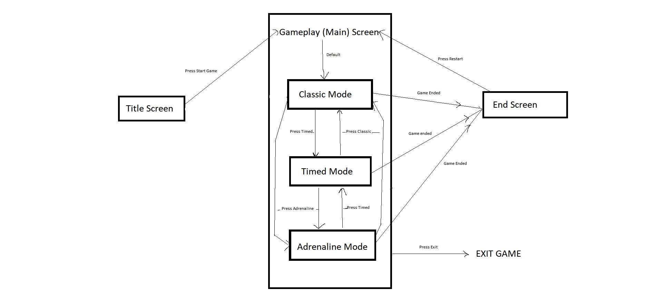

# Pseudo Code

Helping functions and global variables:

* Create Global variables for animation speed, tile size, board size, board offset
* Create struct for tile piece containing tile position and kind and match status.
* Create 2D Array to show a board of tiles
* Swap Function:
  + Swap (tile1 position, tile 2 position.
* Clear Function:
  + For i < board height:  
     For j<board length:  
     board[i][j] = matched //make all tiles matched
* Check Matchable:
  + For each tile in board having row col as i,j:
    - If tile Infront of it has same skin
      * If tile three steps ahead has same skin
        + Set flag and break
      * If tile below or above the tile that is two steps ahead has same skin
        + Set flag and break
    - If tile below it has same skin
      * If tile three steps below it has same skin
        + Set flag and break
      * If tile below or above the tile that is two steps ahead has same skin
        + Set flag and break
    - If tile two steps ahead has same skin
      * If tile above or below the middle tile has same skin
        + Set flag and break
  + If flag set
    - If hint wanted, highlight tile[i][j]
    - Return true
  + Return false
* Is Inside:
  + If mouse x position in between rectangle start and end length x position
    - If mouse y position in between rectangle start and end height y position
      * Return true
* Notification:
  + Draw Notification for 1 second on screen to show passed level

Main Function before loop:

* Create SFML window, Load required textures and images and create required texts and sprites
* Initialize flags and default gameplay values. Current Level=1, Current Mode = 1 (Classic)
  + Title screen has mode 0, Classic, timed and adrenaline have 1,2,3 modes
* Also initialize board as:
  + For each tile:
    - Type=random between 0 and 8
    - Assign row and column inside board
    - Assign x and y inside screen as x=row* tilesize and y=col*tile size
* Start Clock

Main Game Loop:

* Check for mouse pressed
  + Check if inside any button
    - If start button pressed and current mode is zero //title screen:
      * Set current mode=1 and assign default values of classic
    - If restart pressed, clear board and assign default values of current mode
      * Set restarting flag
    - If Classic pressed, clear board and assign default values of classic mode
      * Set restarting flag
    - If Timed pressed, clear board and assign default values of timed mode
      * Set restarting flag
    - If Adrenaline pressed, clear board and assign default values of adrenaline mode
      * Set restarting flag
    - If hint pressed, call check matchable with hint required
    - If Exit pressed, Exit game
  + Store mouse position and calculate offset of mouse relative to board: pos=mousePos-offset
  + Click++
* If currentMode != 0 //not title screen
  + If first click : Highlight tile if mouse pressed on tile
  + If second click: Check if adjacent tile
    - If adjacent, swap tiles using swap function
  + Else click=0
  + For each tile i,j:
    - If tiles ahead and behind it have same type as tile i,j, set all three tiles matched
    - If tiles above and below it have same type as tile i,j, set all three tiles matched
  + Clear moving flag
  + For each tile i,j:
    - If stored coordinates different from default, change them by one to bring them closer to default
    - Set moving flag
  + If not moving:
    - For each tile i,j:
      * If matched, then decrease opacity (deleting animation) by 10 and set is moving
  + Clear Matched flag
  + For each tile, check if matched
    - set match flag
  + If swapped and no match, swap back
  + If not moving:
    - For each tile if matched
      * Swap with tile above until matched tile is at top
    - Replace top if matched tiles with new tiles
    - Update score and tempscore
  + //Use temp score to fill bar
  + If Timed or Adrenaline Mode:
    - If one second passed in Clock
      * Decrement temp score
  + Set progress bar size as same percentage as tempscore * 100 / goal
  + If not moving and not adrenaline mode or if progress bar less than zero
    - Set gameover flag
* Drawing Elements:
  + Clear screen
  + Draw Background
* If current mode != 0
  + For each tile,
    - set texture of temp sprite according to tile type
    - Draw tile
  + Draw all buttons and text
  + Drawl Progress bar
  + If gameover flag is set
    - Draw Gameover
* Else //title screen
  + Drawl Title screen and start button

End Main Game loop^

# Versions of Game Created

1. Created the required global variables and helper functions only and in the main function, drew a basic layout of the game including background and a board with same tiles
2. Added randomness to the tiles being created and added a title screen and its button
3. Implemented mouse click detection and a function to detect if two tiles are swapped
4. Added animation function to the tiles being swapped and extended it to animate any tile not in original position
5. Added the loops to check if tiles are matched i.e. 3 or more tiles in row or column lying next to each other and added animation to slowly make them transparent i.e. make them disappear
6. Added Update grid functionality that creates new tiles and removes old ones by swapping them to the top and replacing them. Also added function to swap back and created check if matches available function
7. Added other buttons and score functionality as well as progress bar and its animation
8. Added functionality for timed and adrenaline mode by starting progress bar in middle and not checking after swapped state respectively
9. Added game over functionality and screen using the check if matchable function, glued everything together finally by giving default values upon button presses
10. Final version. Added Soundtrack and text highlights. Added level up function and level up notification. Added score multipliers and proper time decrement.

# Future Developments

The game implementation leaves a lot of room for both improvement and innovation. Currently, there is not a high amount of “WOW” factor to the game and it is simply a tile matching game. Even though it is competitive with the timed and adrenaline mode, there is a sort of staleness. Further, the board uses an outer boundary to aid in the loops which may take up unnecessary space but for the purpose of the game implementation it really does smooth out the game and make the coding easier. Some errors encountered were that the game would not restart properly because of the various checks in between and not everything was set to default. Another problem was that the adrenaline mode also ended if no immediate matches were available. However, both these problems were easily removed and the game turned out great. The game incorporates the main playability of the original and also introduces a new mode that gets the adrenaline pumping in players. It also ahs graceful animations which were veery hard to achieve in SFML loops.

In the future, the adrenaline mode can have various checks to only allow matching of 5 or more tiles instead of three. Moving on, there can be various effects for example particle effects added when tiles are matched. There is also the possibility of implementing special tiles for example bombs that make all rows and columns disappear. As such, the game has been made with all these things in view and the functions and implementation all have room to incorporate such developments. This would greatly benefit the game as it will remove the “staleness” mentioned earlier and make the game much more engaging as a finished product.

THANK YOU